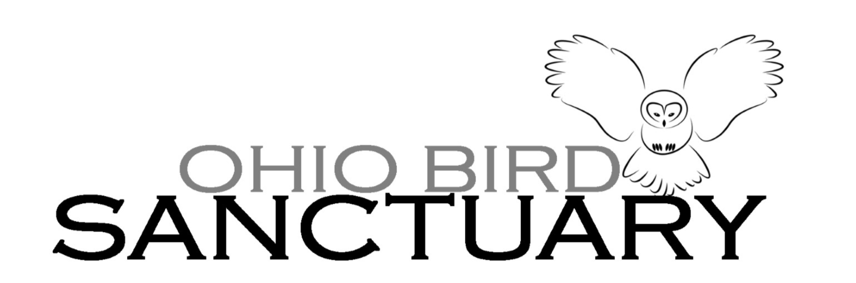

Job Description: Animal Care Specialist
The Animal Care Specialist position is responsible for the daily care of the avian rehab patients, the on-going care and enrichment of our permanent collection animals, and for leading a team. The position begins as soon as possible and reports directly to the Curator of Birds. Salary will be based upon level of experience and qualifications. Benefits include four paid personal days, four paid sick days, five paid holidays, and ten paid vacation days

Responsibilities to the Permanent Collection:
- Maintaining the highest standard of care for all animals
- Developing and implementing enrichment for a variety of species.
- Maintaining cleanliness of enclosures/habitats & following bio-safety protocols.
- Preparing animal diets (including the handling of fresh/raw meat.)
- Observing animals and reporting/documenting health/behavior changes to Curator.
- Handling education animals and delivering educational demonstrations to visitors.
Responsibilities to Avian rehab patients:
- Documenting information on care provided and data required for State and Federal permits.
- Communicating with donors that bring in injured or orphaned birds through our rehab program.
- Continuing to advance the care provided by OBS to improve survival and release rates.
- Maintaining cleanliness of enclosures and following bio-safety protocols.
Professional Qualifications
- College graduate with animal experience required. Veterinary experience/RVT preferred.
- Strong leadership skills required with a natural ability to delegate tasks, prioritize projects, and lead team rounds (including overseeing interns and volunteers.)
- Ability to work in varied weather conditions, be on feet for 10 hours, and lift 40lbs
- Willing and able to work a flexible schedule including weekends and two holidays/year
- Professionalism and a positive approach to work required.

Interested & qualified candidates are asked to submit a cover letter, resume, and optional letter of recommendation to OBS Executive Director, Julie Schwartz at exec.director@ohiobirdsanctuary.com by November 15.

